**Amusement Park Project**

**Introduction**: As a birthday present, your parents are going to drive you and a group of friends to an amusement park. There is just one catch: they want you to research and gather data on the park. Surf the Internet to find how much it will cost for your friends to go to each park. You will use Microsoft Excel to graph and label your findings.

**Process:** Go to the website for each of the amusement parks: 1. Hershey Park, 2. Knoebels (Hand Stamp Price), 3. Dorney Park and Wild Water Kingdom, 4. CedarPoint, and 5. Six Flags Great Adventure. Compute how much it will cost for your friends to enter the park. After gathering all of the information, graph your results.

 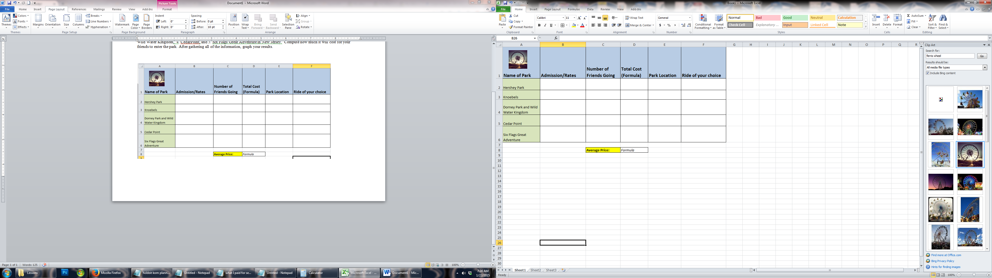

**A. Set Up:**In a new excel workbook. Please set up your spreadsheet to match the grid above. (Include Names of Parks, Admission Rates, Number of Friends Going, Total Cost, Park Location, and Rides of your choice).

**B. Formulas:**

1. For row D you will be using a formula to calculate the total cost. You will be multiplying the admission rate by the number of friends going (make sure you have at least 2 people in this column). The formula for cell D2 is **=b2*c2.** The Formula for cell D3 is  **=b3*c3**. You can do a fill down with this formula!

2. The formula for average price in cell D8: **=average(d2:d6)**.

**C. Directions for Creating the Charts**

1 Highlight the data you want to chart - in this case it will be the flavors, column titles, and the numbers but NOT the percentages or the totals (**Cells A2:B6**)

2 Select Insert from the menu bar, then column chart.  Follow the prompts from the chart wizard and choose the options that best suit your material - it is often a good idea to experiment!

3 After your chart is placed on the screen you can resize it by dragging the corners like a graphic.  Double click on the chart to begin editing and formatting it to suit your needs.